Check for Understanding 3

- If Cat sends Tac a message, then which one is Tac’s program?

- 

- 

- 

- Which program will make Cat get smaller while moving forward?

- 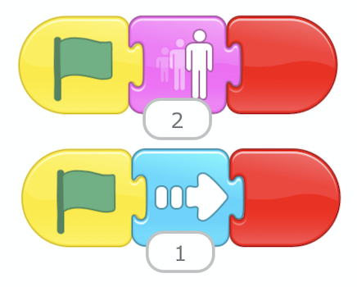
- 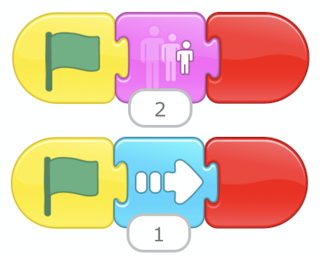

- Cat wants to move 3 steps forward while also playing a “pop” sound and then tell Tac to chase them. If this is Tac’s program:



Which program would be Cat’s?

- 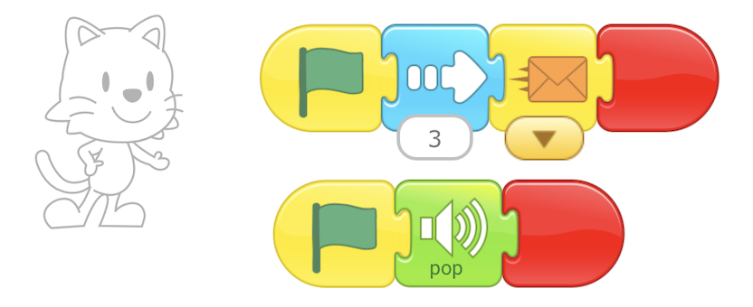

- 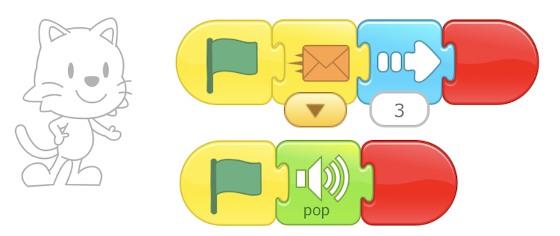

Coding As Another Language (CAL) for ScratchJr (CAL-ScratchJr) - 2nd grade © [2020 - 2025] DevTech Research Group. Some Rights Reserved.
Coding As Another Language (CAL) for ScratchJr (CAL-ScratchJr) - 2nd grade is licensed under Creative Commons Attribution-NonCommercial-ShareAlike 4.0 International. To view a copy of this license, visit https://creativecommons.org/licenses/by-nc-sa/4.0/
This license requires that reusers give credit to the creator. You may distribute, remix, adapt, and build upon the material in any medium or format, but must license the modified material under identical terms and indicate what has changed from the original. You may not use or adapt this work for commercial purposes.

